



adges UI components library

**Component ID #1 – ex-img-card - v1.0.0**

## Document Control

## Version History

|  |  |  |  |
| --- | --- | --- | --- |
| Version | Date | Author | Reason for Change |
| 1.0.0 | 2019-10-28 | Mahmoud |  |
| 1.1.0 | 2020-23-20 | Rijin Mukundan |  |
|  |  |  |  |
|  |  |  |  |
|  |  |  |  |
|  |  |  |  |
|  |  |  |  |
|  |  |  |  |

## Review History

|  |  |  |
| --- | --- | --- |
| Version | Reviewer | Date |
|  |  |  |
|  |  |  |
|  |  |  |
|  |  |  |
|  |  |  |
|  |  |  |
|  |  |  |

Table of Contents

Document Control 1

Version History 1

Review History 1

1. Document and components Purpose. 3

2. General Information. 3

3. How to use. 3

4. Component features and configure. 4

5. How to configure component. 4

6. Examples 4

# 

# Document and components Purpose.

The purpose of the document is to guide how use and configure **ex-img-card** component.

Component Name: Img-card.

Extension Theme: ex-img-card.

Owner: Mahmoud.

Version no: v1.0.0

Design

**Variant v1**

**Variant v2**

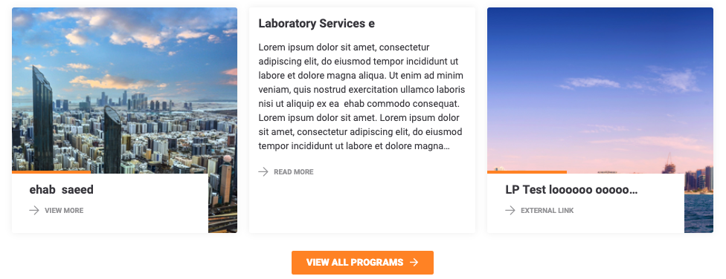

# How to use.

1. The available commands for this project .
   1. Compile : npm run gulp compile -- –path ex-img-card –extension
   2. Compile & include under ADGE tenant : npm run gulp compile -- –path ex-img-card –extension –full –dest [ADGEFolder]
   3. Deploy : npm run gulp deploy -- –path ex-img-card –extension
2. *Now project have full copy from this extension theme under the project theme and you can apply the project brand guideline and configure component based on project needs.*

# Component features and configure.

You have access now to configure component with the below item.

$img-card-height:100% !default;

$img-card-img-height:380px !default;

$img-card-img-small-height : 250px !default;

$img-card-width:305px !default;

$img-text-cont-width:260px !default;

$img-card-text-cont-height:100px !default;

$img-card-icon-padding:10px !default;

$img-card-read-mor-fs:12px !default;

$img-card-strip-color:$primary-color !default;

$img-card-strip-width:35% !default;

$img-card-strip-height:5px !default;

$img-card-strip-top:-5px !default;

$img-card-icon-color:$grey-600 !default;

$img-card-icon-hover-color : $grey-900 !default;

$img-card-container-after-hover-height:100% !default;

$img-card-container-after-hover-bg:$white-color !default;

$img-card-container-after-hover-top:0% !default;

$img-card-container-after-hover-opacity:1 !default;

$img-card-container-after-hover-aligmnet:0px !default;

$img-card-container-after-hover-width:100% !default;

$img-card-container-after-hover-transition:.3s !default;

$img-card-container-align:13% !default;

$img-card-container-content-align:-13% !default;

$img-card-container-content-bottom:0 !default;

$img-card-container-content-before-left-rtl:auto !default;

$img-card-container-padding: 15px !default;

$img-card-container-margin:0px 15px 15px 15px !default;

$img-card-container-image-icon-padding:0px !default;

$img-card-link-font-size : 11px !default;

$img-text-cont-bg:$white-color!default;

$img-text-cont-bg-opacity : 0.9 !default;

$img-card-container-reset-img-card-title-padding:30px!default;

$img-card-container-add-border-radius:10px!default;

$img-card-container-add-border-radius-after-hover:0px!default;

$img-card-scale:scale(-1) !default;

$img-card-box-shadow:0 0 12px 0 color-opacity($black-color, 0.07) !default;

$img-card-upper-case:uppercase !default;

$img-card-header-height:25px !default;

$img-card-title-color:$grey-900 !default;

# How to configure component.

There are various ways to configure the component:

1. **CSS Class Configuration (on the variant)**

These styles can be applied in the variant to get the desired result

|  |  |
| --- | --- |
| Feature | Modifier |
| switching the positions of the card text from left to right or right to left in arabic | .ex-img-card__container__content--switch |
| Adding rounded border to the card text container | .ex-img-card__container__content--border-radius |
| Using the alt height for this component | .ex-img-card--small |
| Adding box shadow to this component | .ex-img-card--shadow |

Add this class to the div of content in order to add border radius to the content

--border-radius

<div class="ex-img-card__container__content  ex-img-card__container__content--border-radius  ">

Add this class to switch the content div to the other side

--switch

 <div class="ex-img-card__container__content ex-img-card__container__content--switch ex-img-card__container__content--border-radius position-absolute">

1. **Adding Built-In or Bootstrap Class (on the variant)**
   1. Spaces, Font weights, Display, Position properties etc can be added by bootstrap classes
      1. i. Spacing: <https://getbootstrap.com/docs/4.0/utilities/spacing/>
      2. ii. Flex: <https://getbootstrap.com/docs/4.4/utilities/flex/>
      3. iii. Font: <https://getbootstrap.com/docs/4.0/content/typography/>
   2. These classes should only be added to match the design
   3. For built-in classes check 7 Below to see the entire list
2. **SCSS Variable Override (on the _override.scss file)**

To configure the component we can take the above variables from section **3. Component features and configure** and add them to: adge-ph2/themes/<ADGE>/vars/_override.scss, this file with your desired changes to match the design.

1. **Complete style override**
   1. This should be the last and final option if the above 3 didn’t get you the desired output
   2. This is overwriting the SCSS of the component by adding your own style to it
   3. **Note: Take permission before doing this override**
   4. Instructions:
      1. Open the file /adge-ph2/themes/<ADGE>/sass/overrides.scss and add your own SCSS styles to override the faulty component.

# Dependencies

components-img-card.css

component-truncate.js

components-img-card.js

# Examples

Examples1:

I need to change text color.

I’ll copy the below variables from extension theme.

$highlight-main-tittle-color: $primary-color;

Then will paste the above variable in project folder theme in file _custom.scss and change with any variable based on site needs.

$highlight-main-tittle-color: $secondary-color;

Examples2:

I need to the button shape from square to had a rounded corner.  
I’ll copy the below variables from extension theme.

$button-shape-square: $border-radius-value;

$border-radius-value: 0px;

Then will paste the a above variable in project folder theme in file _custom.scss and change with any variable based on site needs.

$button-shape-square: $border-radius-value;

$border-radius-value: 20px;